“The Battle of Neighborhoods”

in Old Toronto

Introduction, The business problem
The current study will try to provide an optimum location for opening a new business in a specific city, based on:
- A neighborhoods property, e.g. the second most common language spoken (after English) in the neighborhood,
- The number of competitors in the neighborhood, • The population density in the neighborhood.
- The average income of the neighborhood.

Let's investigate in the old City of Toronto (Canada), and propose the best possible place for opening a new restaurant with ethnic cuisine. Assume that preferably we would like the new restaurant to be located in a neighborhood with a high degree of the same ethnic characteristics, i.e. assume the languages spoken in that neighborhood, so to make advantage of the cultural element of the area. In order to sustain the new business, there should be a lot of population, the less number of competitors possible. The restaurant should be of middle class and above.

The results could be highly usable for people having ethnic cooking skills or restaurant-businessmen, who want to open an ethnic restaurant in a neighborhood having some degree of the same ethnic culture in Old Toronto.

2. Data description
The datasets that will be used are for retrieving information about city's neighborhoods and their characteristics are taken from Wikipedia website for the Toronto demographic information:

- https://en.wikipedia.org/wiki/Demographics_of_Toronto_neighbourhoods

The geographic coordinates of the neighborhoods of Old Toronto are taken from:

- File 'Toronto.csv' which the latitude and longitude per neighborhood in Old Toronto area.

Combining the above data sets, we get demographic information, focused in Old Toronto's neighborhoods and the exact coordinates per neighborhood. Then by using the Foursquare API, we can retrieve further information for venues, venue categories and venue coordinates for every area. The Foursquare data set combined with the neighborhood's data set with demographic information will be the main data set that we will be used for the analysis. Visualization of the results via maps and graphs, where possible, will help to explain the data.

Based on the language spoken (second language spoken after 'English'), the neighborhood's population, the level of wealth, and the number of ethnic restaurants (restaurants with ethnicity common with the language spoken) the best possible set of candidate neighborhoods can be retrieved. Then by using k-means algorithm the candidate neighborhoods will be further analyzed. The final results, via tables and maps will conclude on finding the best neighborhood to start an ethnic restaurant in an ethnic-cultural neighborhood, show any existing patterns and similarities between ethnic restaurants and ethnic populated neighborhoods in Old Toronto area.

3. Methodology

1. Data wrangling
For first step, the information in the Wikipedia link has to be transformed in a suitable form that enables further dataframe analysis. The link that provides the demographic data is the following:
'https://en.wikipedia.org/wiki/Demographics_of_Toronto_neighbourhoods'
By using ‘BeautifulSoup’ we retrieve the json data and fetch the wanted tags. We then clear the data via regular expressions for unwanted characters (e.g. remove '\n', empty spaces, etc.), remove non-meaningful data, rename index and columns and the dataframe with the demographic data is as shown below (df : demographic.head(10)):
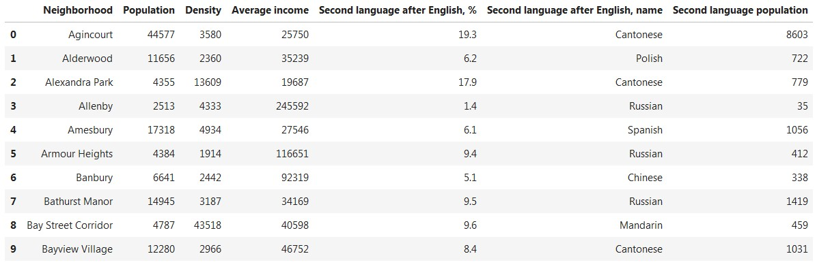
Each neighborhood is depicted via its population, density, average income, the most common language after English spoken in the area (assume it as named as ‘language’ from now on), the name of the language, the population speaking that language (assume it as ‘ethnic population’)

2. Add coordinates in the demographic data
It is possible to add latitude and longitude data, by merging the demographic dataframe and the neighborhoods of Old Toronto only. File ‘oldToronto.csv’ contains the coordinates of Old Toronto. The updated dataframe is as shown below (df :
Toronto.head(10) ):

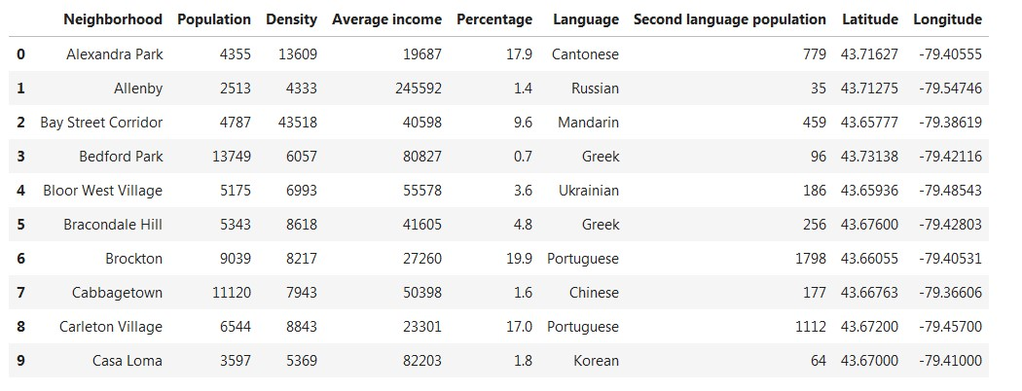
We can visualize the map of Toronto, with the neighborhoods, the language used (after English) – which depicts the ethnic group, the percentage of the ethnic group. Different color is used for each language (e.g. ‘pink’ is used for ‘Portuguese’). (map:
map_Toronto_neighborhoods)

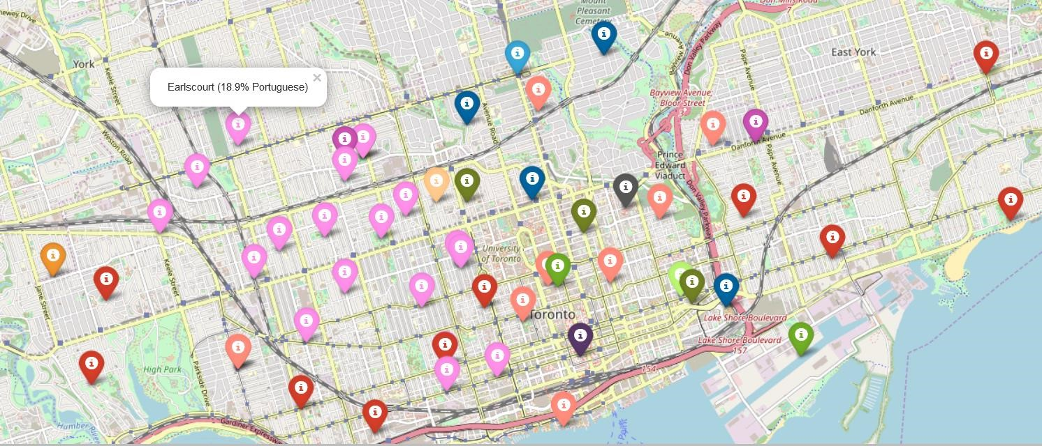

3. Foursquare API
Now that we have the demographic information per neighborhood in Old Toronto, lets collect all venues within 1km radius from the center of each neighborhood (limit to 100 venues) and store the results in a dataframe (df: Toronto_venues.head(10)):
- Alexandra Park
- Allenby
- Bay Street Corridor
- Bedford Park
- Bloor West Village
- Bracondale Hill
- Brockton
- Cabbagetown
- Carleton Village 9 Casa Loma
- Chaplin Estates
- Christie Pits
…
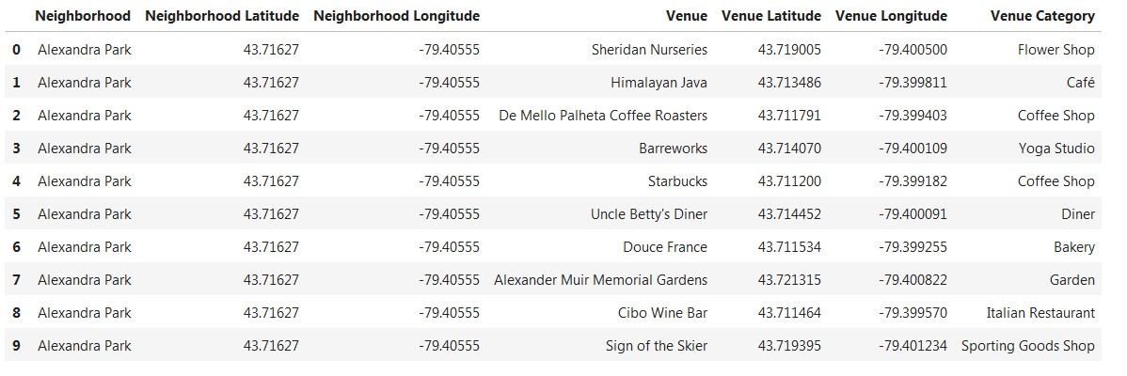

We only interested in ‘Restaurants’ so we filter the venue category by this type (df:
Toronto_restaurants_coord.head(10)):
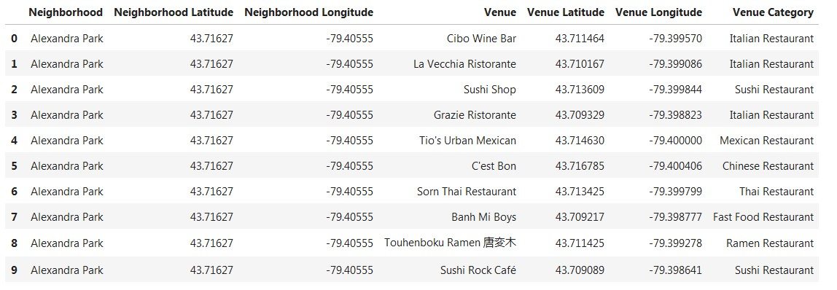
Then we calculate the sum of ethnic restaurants per neighborhood (note ethnic assumed the ethnic group speaking the second most common language after English in the area, (Toronto_restaurants.head(10))).

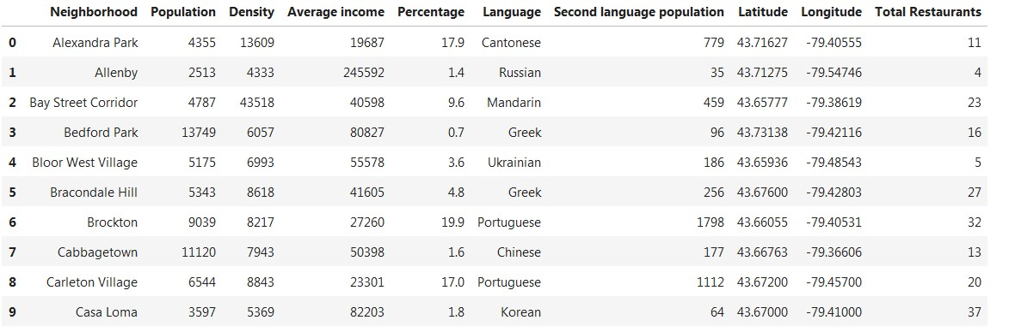

Since a language can be spoken by more than one country (and represent more than one cuisines), the following speaking groups are formed:
For Portuguese assume common ethnic group for Brazilian and Portuguese Restaurants. For Japanese assume common ethnic group for Sushi and Japanese
Restaurants. For Cantonese assumed common ethnic group for Thai, Taiwanese, Vietnamese, Cantonese, Indonesian Restaurants. For Mandarin as Chinese for Chinese Restaurant. This is important as it enables to differentiate the ethnic restaurants per neighborhood. These restaurants will be the competitors if we want to open a new ethnic restaurant (df: Toronto_restaurants_conclude.head(10)). We remove for now the ‘Average income’ and ‘Density’ columns:

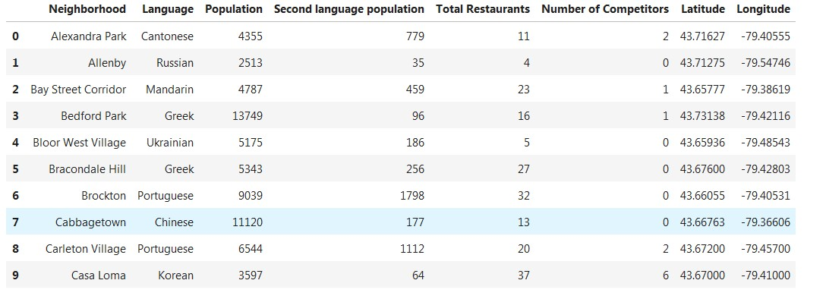

We can then visualize in a map the number of competitors for each neighborhood:

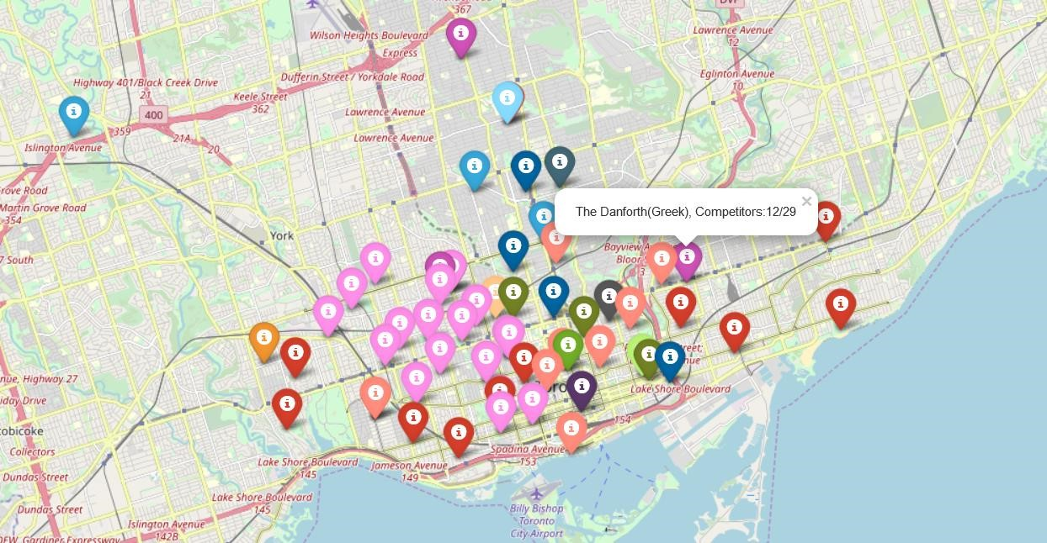

4. Introduce weight factors

Based on the initial requirements, to have the less competition possible, it is needed to introduce a new factor to depict the “Density of ethnic restaurants (same as language) out of total restaurants” (less is best). According to this factor the neighborhoods that should be avoided due to high number of competitors (ethnic restaurants same as the language spoken), is as follows:
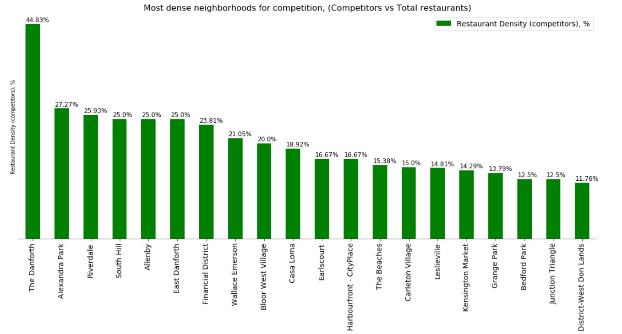

We can see that “The Danforth”, “Alexandra Park” and “Riverdale” are highly competitive for these kind of business and better to be avoided.

Similarly for the requirement to have strong ethnic presence in a neighborhood, the density of ethnic population over the total population is introduced (large is best). Neighborhoods such “Little Portugal”, ‘Brockton”, “Wallace Emerson” have a high degree of the dominant language-ethnic groups. They should be considered in relation to average income and population later on if they are good candidates.

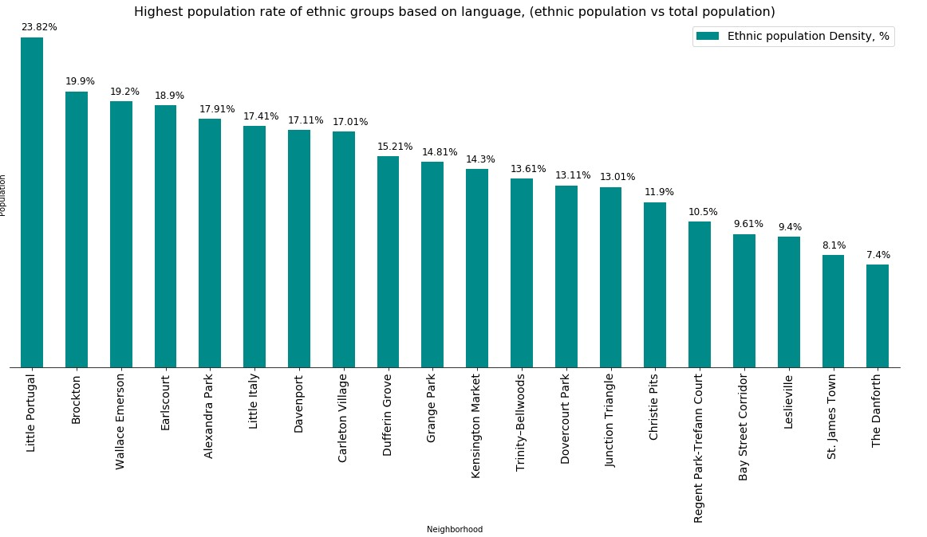

We combine the 2 density factors with the main dataframe to a final dataframe, as shown below (df: Toronto_restaurants_final.head(10)):

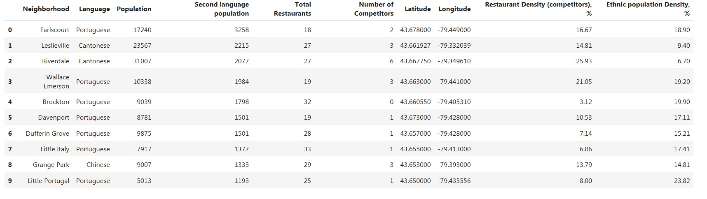

4. Results
We could manually try to search for the optimum location base on the following criteria:
- Assume middle-class and above neighborhoods only, i.e. merge the dataframe with the ‘average-income’ available from demographic information. Find the average income and filter neighborhoods above the man value, i.e. middle and above class.
- Large population, so to attract as many people as possible. Further filter the above dataframe for neighborhoods with population above the mean population value
- Large ethnic community, so to have significant cultural characteristics. Consider for ethnic group significant high, i.e. above average number of all ethnic groups.
- Less number of competitors, so to avoid competition as much as possible. Based on restaurant density we keep only the neighborhoods where the competition is below the average number of competitors.

The result is (df: T_manual):
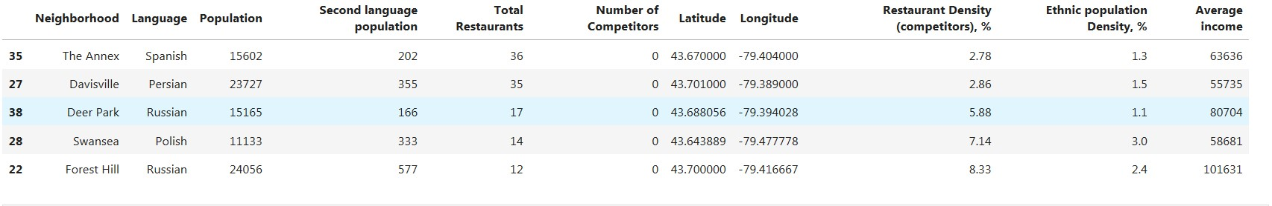
Conclusion by observation:
“The Annex” is the first candidate, although “Davisville” has larger population and similar restaurant and population density, i.e. “Davisville” is better. “Deer Park” and Swansea have less ethnic population and larger restaurant densities, i.e. no good. “Forest Hill” is similar to “Davisville” but with mush worse density factors.
The winner seems to be “Davisville” for opening a Persian, medium-upper class restaurant.

Analysis of results by machine learning (k-means)
Let us add to the main dataframe “Toronto_restaurants_final” the information about the average income, since this is relative with the type of restaurant that will open, i.e. lower, middle, upper, high class and then try to apply the k-means algorithm and see the results.
For the clustering algorithm, a cluster of 5 groups (k=5) will be sufficient for the analysis. The following clusters are formed:
Cluster0:
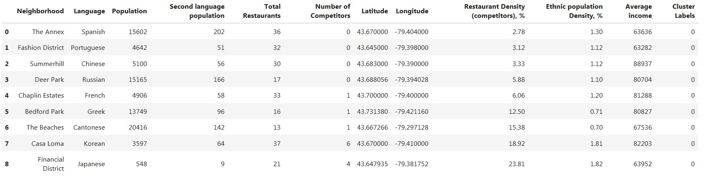
Cluster1:
Cluster2:
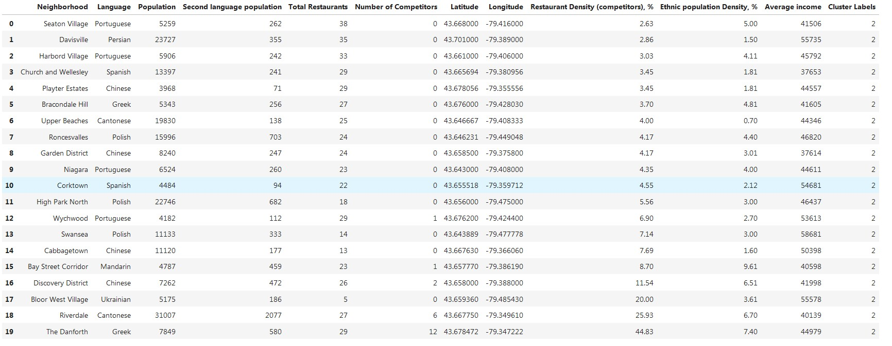
Cluster3:
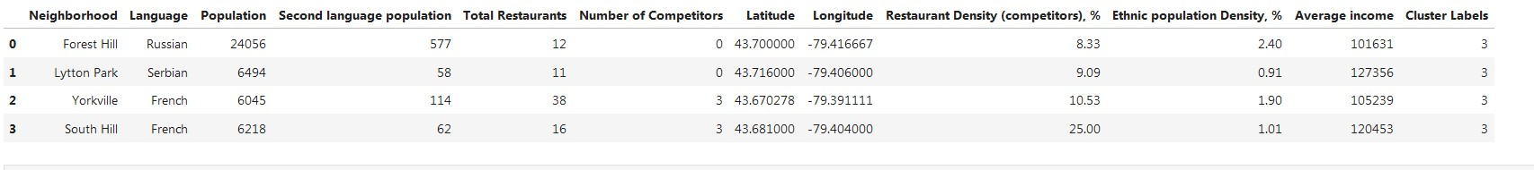
Cluster4:
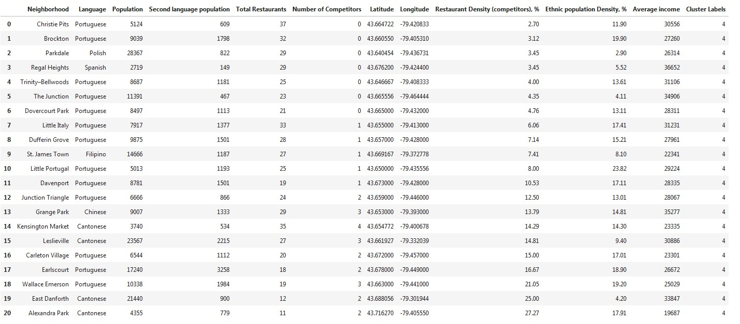
The above results can be visualized in a map as follows:
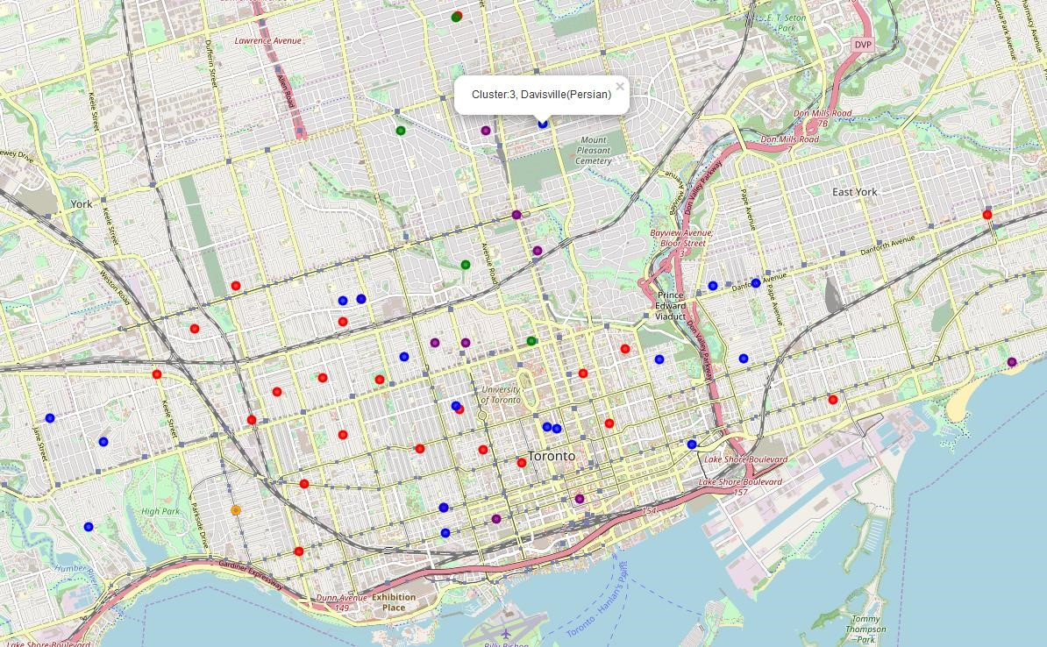

5. Discussion
We can see from the results, that the main factor that the machine learning algorithm has used to divide the neighborhoods is the ‘Average income’ data. This property proved to be the more decisive from all other properties of the neighborhoods.

In more details per cluster, we can see the following:

Cluster 0, has the upper-class population (60k – 90k). All neighborhoods either have small ethnic group, or small population relative to neighborhoods of other clusters. “The Annex” (Spanish) seems to be the best option for this group. Not efficient enough.

Cluster 1, has the most expensive areas (>200k), although the population at these areas is small and the ethnic group small, i.e. The areas do not represent a high a cultural neighborhood. Not efficient enough.

Cluster 2, has middle class areas (40k – 50k). We could say that being at the average class, both low-level and high-level income citizens can be attracted, i.e. this is the most representative group of neighborhoods. Let us further filter for population more than the average of the cluster (df: Cluster2_final):

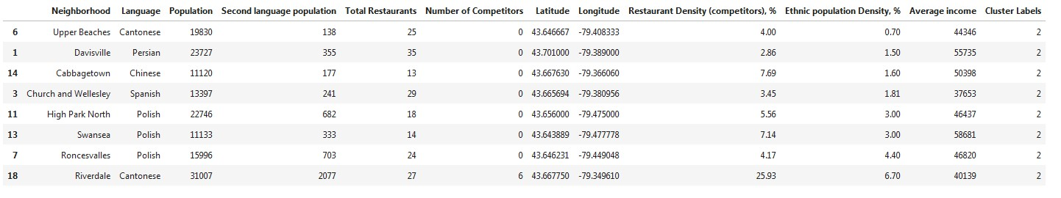

The strongest ethnic groups are at “Davisville”, “High Park North”, “Roncesvalles” and “Riverdale” (max). From all the above “Davisville” (Persian) has the lowest competition (1.5%) and the second largest population after “Riverdale”. So for this cluster and overall clusters, “Davisville” (Persian) is the best option for opening a new Persian restaurant (middle-class).
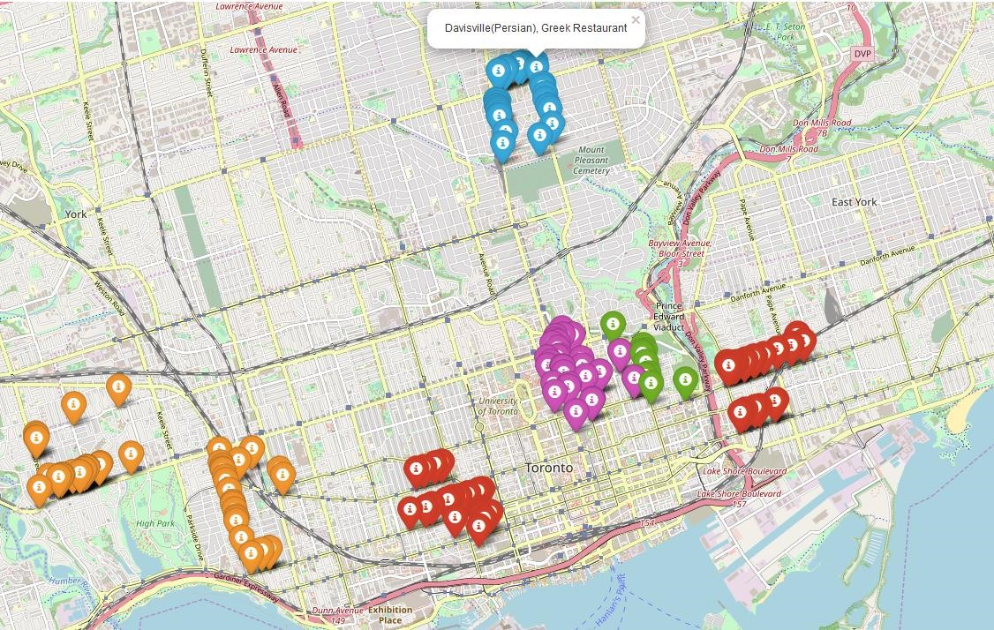

Cluster3, has high-class areas (>100k). Small ethnic groups relatively to population and not many restaurants in the area. “Forest Hill” (Russian) seems the exception and for this cluster is the best option. For high-class restaurant “Forest Hill” (Russian) is the best option.

Cluster4, has the low-class areas (<35k). At these areas there is very high competition for almost the half of the neighborhoods. Best of all seems to be “Parkdale” (Polish) with very high population, very strong Polish group representative, no competition for other ethnic restaurants and relatively low competition from other types of restaurants. For low-level class “Parkdale” (Polish) is the clear winner.

Conclusion
We have analyzed the neighborhoods of Old Toronto with respect to
- Population
- Competition
- Ethnic group presence (language oriented) • Average income

The results from observation are the same as the ones from applying the k-means algorithm. The ‘Average income’ was the most distinctive property for the neighborhoods, more important than other significant properties such as the population. Below the best candidates, based on “Average income”:

The best option to open an ethnic Persian restaurant is “Davisville”. This area has less competition, and second best population from other candidates. It is in area with average income, i.e. can attract better all classes equally, in contrast to “Forest Hill” which seems rather expensive.

Below a map of competition in Davisville (restaurant types are represented via different colors):
